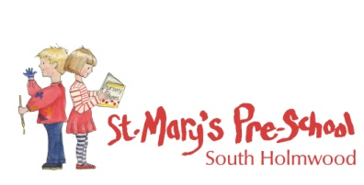
Equality of Opportunity

St Mary’s Pre-school will ensure that our service is fully inclusive in meeting the needs of all children, particularly those that arise from their ethnic heritage, social and economic background, gender, ability or disability. Our Setting is committed to anti-discriminatory practice to promote equality of opportunity and valuing diversity for all children and families.

