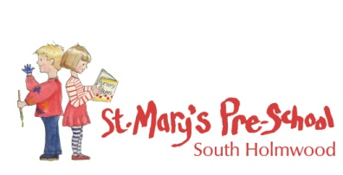
Information Sharing
St Mary’s Pre School recognises that parents have a right to know that information they share will be regarded as confidential, as well as to be informed about the circumstances and reasons when we are obliged to share information.

We have a duty to share confidential information, without consent from the person who provided it or to whom it relates, if it is in the public interest:
- If it is to prevent a crime being committed or intervene where one may have been, or to prevent harm to a child or adult.
- Not sharing it could be worse than the outcome of having shared it.

The three critical criteria are:
- Where there is evidence that the child is suffering, or is at risk of suffering, significant harm.
- Where there is reasonable cause to believe that a child may be suffering, or at risk of suffering, significant harm.
- To prevent significant harm arising to children and young people or serious harm to adults, including the prevention, detection and prosecution of serious crime.

