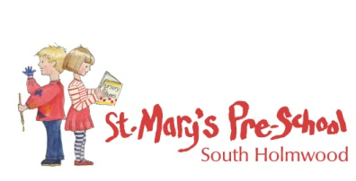
Making a Complaint

St Mary’s Pre-school believes that children and parents are entitled to expect courtesy and prompt, careful attention to their needs and wishes. We welcome suggestions on how to improve our Setting and will give prompt and serious attention to any concerns about running the Setting. We anticipate that most concerns will be resolved quickly by an informal approach to the appropriate member of staff. If this does not achieve the desired result, we have a set of procedures for dealing with concerns. We aim to bring all concerns about the running of our Setting to a satisfactory conclusion for all parties involved.

For full details see our Policy ‘1.12 Information and Records - Making a Complaint’ in the policy file located on the noticeboard.

