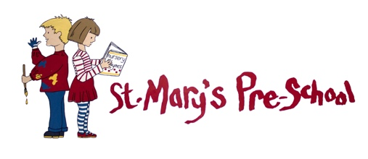

P R O S P E C T U S

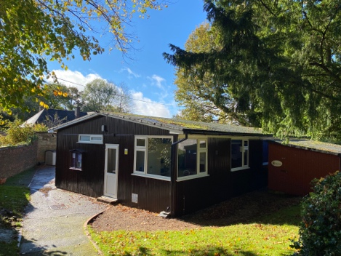
The St Mary’s Pre-school is a Charitable Incorporated Organisation (“CIO”) run by a Committee of Trustees and is registered with Surrey County Council, and Ofsted. We are registered with Surrey County Council to provide FEE funding for 3 & 4 year olds and FEET funding for eligible 2 year olds. We are also members of the Early Years Alliance.

Our Pre-school is situated in the grounds of St Mary Magdalene Church in the village of South Holmwood. We provide a warm, friendly Pre-school environment within which the children are offered a safe, stimulating, happy, fun and challenging learning environment.

Mission Statement
We believe that all children are unique, and we ensure that no family is discriminated against. As all children learn at different rates and in different ways, it is our goal to achieve the very best for each child and help them to develop to their full potential. We always strive to be the best we can and continually look for ways to improve our provision.

OUR ETHOS

- Children will learn through independent play, routines, conversation, and ‘Awe and Wonder’
- Children will be outdoors as much as possible
- Children will be supported to be independent in their self-care
- Children will be supported to learn by doing things just beyond what they are capable of
- Children will be allowed to take responsible risk-taking and set their own challenges
- Children will be praised for their effort rather than their product
- Children will be supported to problem solve, physically, mentally and emotionally
- Children will be given ample time to practice their newly acquired skills
- Children will be supported to make choices resources will be easily accessible
- Children will be listened to and supported to listen to others
- Children will be supported to collaborate, to be kind and caring to others and the environment, and to show empathy.
- Children will be celebrated for their uniqueness and individuality, so they develop a strong sense of self and confidence in their own abilities.
- Children will be nurtured in a warm and caring environment to develop a sense of belonging at The St Mary’s Pre-school.

CURRICULUM
Our aim is to provide children with the experiences and opportunities to help them to progress and achieve success. In partnership with parents, we will endeavour to give them everything they need for what comes next in their learning and development.

Communication and Language
We recognise that all children have individual experiences and a unique foundation for communication and language, not only at the point of joining Pre-school but throughout their time with us.

The development of children’s spoken (expressive) language underpins all seven areas of language. Children will also be supported to develop the necessary foundation skills of attention and listening, and play and interaction, together with a strong understanding of (receptive) language.
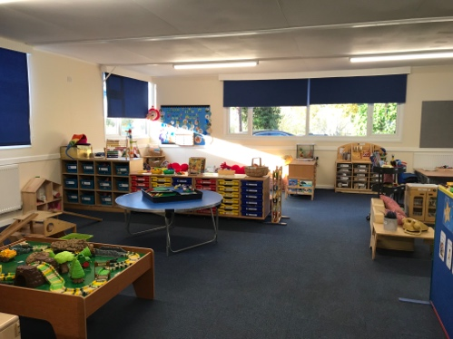
Children will have access to a language rich environment with responsive communication partners so they can practice back and forth interactions to develop confidence as effective communication and language users. Staff will join in with children’s play and comment, repeat back, wonder aloud, and add new words to extend language. Ideas will be shared with parents to support the children at home.

Sensitive questioning will be used to encourage interaction and we will plan opportunities for the development of a broad, creative, and imaginative vocabulary. The link between Literacy, Communication and Language will not be under-estimated, and we will read stories aloud, and share books at regular times throughout the day to support emerging literacy to develop language, and to help children understand new concepts.

We recognise that a child’s first language provides the roots to learn additional languages and we will support, and encourage parents, to continue to use their home language at every opportunity for linguistic and cultural reasons. We will celebrate multilingualism for the benefit of all our children.

Personal, Social and Emotional Development
Who we are (Personal), how we get along with others (Social), and how we feel (Emotional), are fundamental to all other aspects of development and learning, and vital for children’s well-being and resilience.

This foundation will be built by offering a safe, secure environment where healthy attachments and relationships are fostered. Through these relationships, children are helped to begin to understand and label their feelings, and those of others, and be able to manage those feeling and emotions. Staff meet the emotional needs of children by drawing on their own emotional insight, and by working in partnership with families to form warm, nurturing relationships with each of their key children.

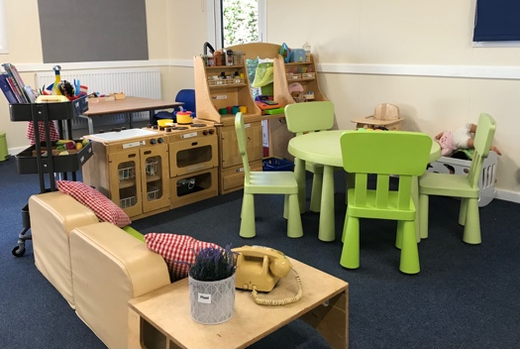
Children are supported to develop a positive self-esteem, achieve self-identified goals, have confidence in their ability, as well as be able to persevere when things go wrong, and wait when required to do so.

Positive relationships and friendships are achieved by adult role modelling, support, and small group opportunities.

Children will learn how to look after their bodies and begin to understand the importance of physical exercise and consuming a healthy diet.

We live in a social world, where positive mental health has a direct effect on children’s life outcome, The St Mary’s ethos reflects the recognition of this fact.

Physical Development
Physical activity, both indoors and out, are vital for a child’s all-round development and wellbeing, and enables them to pursue a happy, healthy, and active life.

It is our aim to support children to develop their core strength, stability, balance, spatial awareness, co-ordination, and agility, and to support them to risk-take safely, with confidence to build self-esteem.

Fine and gross motor control must develop together in an integrated way, so that children have the necessary skills to achieve what they set out to do.

Fine motor development: As hand-eye co-ordination helps a child develop their early literacy skills, it is our aim to provide children with lots of opportunity and support to confidently develop these skills. We achieve this by providing a good range of activities and continuous provision such as small world, arts and crafts, cooking, threading, and by using small tools such as scissors, tweezers, and hammers.

Gross motor development: In order for children to develop a healthy body, and to aid their social and emotional well-being, they will be supported to engage in physical activities both indoors and out. Children will be supported to develop fluidity of movements, taking joy and pride in what they do. Staff will use a variety of physical experiences to help children to remember a sequence of movements during active games, and as a result support the development of vital executive functions.

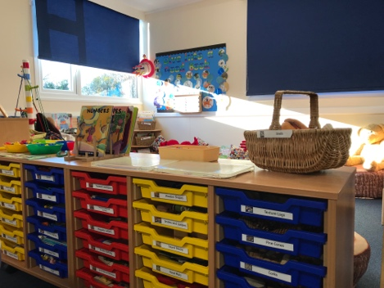
Literacy
We recognise that early literacy skills are rooted in a child’s enjoyable experiences from birth; gesturing, talking, singing, playing, reading, and writing. Children will be supported to interpret, create, and communicate meaning through writing and reading in different media. Spontaneous opportunities are seized for reading and exploring books both non-fiction and fiction, rhymes, poems, and nursery songs. Attentive adults will recognise and value a child’s choices and support the development of new vocabulary.

Children are encouraged to develop their pre-writing and writing skills through fine manipulative opportunities, tool handling and exploratory mark-making.

Maths
To develop Master Mathematicians, we embed children’s deep understanding of numbers 1 to 10. They will be confident to sequence, notice patterns and recognise small groups with and without the need to count. Opportunities and resources are varied and present in all areas of our provision to support this skill.

Children develop their spatial intelligence in all areas of maths including space, shape, and measure by exploring and manipulating a rich array of continuous provision. Children will be mathematical explorers, confident to express their thoughts and findings, adopt a ‘trial and error’ technique, and be comfortable and challenged by this.

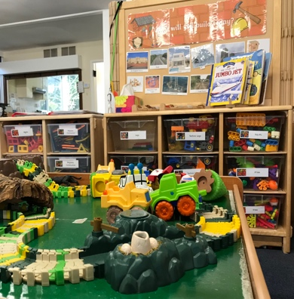
Understanding the World
We recognise that children enter with a range of experiences provided by their families, and staff will build close relationships with parents to develop a deep understanding of their cultural capital. Children will develop upon this already established understanding, knowledge and experience by broadening and extending their understanding of the world, celebrating the diversity within it, the impact and value of technology and the importance of sustaining the current world we live in. Children will be nurtured to be investigative, curious, invested in the world in which we all live, and to adopt an ‘Awe and Wonder’ attitude.

We will achieve this by enabling regular and direct contact with the natural, built, and virtual environments. Children will have active involvement in our local community to develop a sense of belonging and help support our British values. Children will be given regular real-world experiences and first-hand involvement in caring for the natural world, so they develop an appreciation for environment care.

Expressive Arts and Design
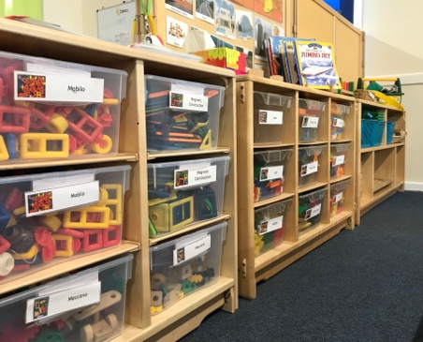
Expression conveys both thinking (ideas) and feeling (emotion). We will support children to be able to express and communicate through music, movement and by using a variety of media and materials. Adults understand the importance of original responses to develop creative thinking, not just imitating existing artwork. Children will be encouraged to be imaginative, curious and experimental, and to use critical thinking when engaging in sustained shared thinking with both adults and peers. Children are given the necessary time, space and opportunities to enquire about the world and to reflect on their experiences. Adults will support children to appreciate diversity to enrich their way of thinking.

Developing children’s imagination and creativity fosters increased understanding, a self-expression, vocabulary, and the skill to communicate through art. A plethora of opportunities, experiences, and wide varied range of resources to engage, explore and play with support children’s progress in interpreting and appreciating what they hear, respond to, and observe.

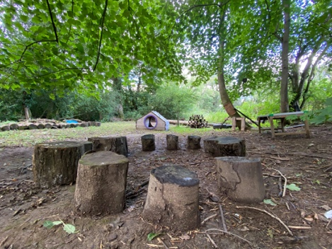
Forest School
Our Forest School Ethos is based on a fundamental respect for children and for their capacity to instigate, test and maintain curiosity in the ‘World Around Them’. It believes in children’s right to play; the right to access the outdoors (and, in particular a woodland environment); the right to access risk and the vibrant reality of the natural world; and the right to experience a healthy range of emotions through all the challenges of social interaction, to build a resilience that will enable continued and creative engagement with their peers and their individual potential. We are fortunate to have access to a beautiful outdoor learning space within walking distance of our building and we utilise this as much as possible all year round.

OPENING TIMES
We offer ten sessions a week, Monday to Friday from 9.15am to 12.15pm and from 12.45pm - 3.45pm (Working parents may drop their child off at 9am on their working days). Children may stay all day, accessing 2 sessions in one day by attending the additional lunch service (12.15pm to 12.45pm with a packed lunch which is provided by the parent/carer).

STAFF
We have a very high ratio of adults to children, this ensures your child has their needs (including education, development, toileting, nappy changing, handwashing, and general matters of care and comfort) recognised, tailored and met.

Our staffing includes ten qualified level 3 practitioners, two 1:1 support workers, three unqualified practitioners and one Administrator. We are committed to ensuring the continuous professional development of our staff, regular training is accessed for both individual and group learning.

Key Person
We believe that children thrive from a base of loving and secure relationships. This is normally provided by a child’s Parents/Carers but can also be provided by a Key Person. A Key Person is a named member of staff with responsibilities for a small group of children, helping those children in our setting to feel safe and cared for.

Their role is an important one and is set out in the Early Years Foundation Stage “EYFS” as an approach that works successfully in settings. It involves the Key Person responding sensitively to children’s feelings and behaviours, meeting emotional needs by giving reassurance such as when they are new to our setting, and to supporting the child’s learning and well-being. The Key Person supports physical needs too, helping with issues like nappy changing, toileting and dressing when appropriate. Your child’s Key Person will become a familiar figure who is accessible and available as a point of contact for parents, and who builds relationships with the parents or carers.

All children attending The St Mary’s Pre-school have a personal online Learning Journey (accessed via a safe, password protected, website service called Tapestry) which records photos, observations and comments in line with the Early Years Foundation Stage. Working in partnership with Parents/Carers, this enables us to build up a record of each child’s learning and achievements during their time with us.

FEES

FUNDED CHILDREN
Universal (also known as “15 hours”)
St Mary’s Pre-school operates during term times only (38 weeks per annum), offering up to 15 hours free entitlement to all children, beginning the term after their third birthday. This means that children can take their free entitlement of up to 15 hours over the 10 sessions offered weekly by St Mary’s.

Extended Entitlement (also known as “15+ hours”)
We offer up to an additional free 15 hours (equalling 30 hours in total) over the 10 sessions weekly if both parents are working (or the sole parent is working in a lone parent family), and each parent meets the earnings criteria detailed below. To receive the additional 15+ hours parents will need to apply via the online Government portal through the HMRC website, Childcare Choices.

Earning Criteria:
- Each parent must be working (or the sole parent in a lone parent family) and earn, or expect to earn, the equivalent to 16 hours minimum wage or living wage per week.
- Each parent must earn below £100,000 per annum.
- You are eligible whether you are in paid employment, self-employed or on a zero hours contract.

Funded hours can be shared across other settings and childminders. Parents will need to re-confirm their eligibility every three months via the online portal to continue claiming any additional 15+ hours. If parents no longer meet the criteria, they will not be able to claim any additional 15+ hours free provision, however they will be given the option to pay for these extra sessions at our non-funded rate. Universal 15 hours will not be affected by this. For more details go to: https://www.childcarechoices.gov.uk

FEET FUNDING
All two-year-old children who meet the qualifying criteria, can claim 15 hours funding from the term after their second birthday, but will not be entitled to the additional 15+ hours until they receive the universal funding of 15 hours the term after their third birthday. Please speak to a member of staff if you think you may be entitled to this funding.

NON-FUNDED CHILDREN
St Mary’s is open 10 sessions per week to all children once they pass their second birthday. A fee is charged, for each 3 hour session.

Allocating Spaces
St Mary’s offers 10 x 3 hour sessions per week over 5 days, Monday to Friday 9:15am to 12:15pm and 12:45pm to 3:45pm, with an optional lunch service 12:15pm to 12:45pm, so that children can stay all day (the lunch service is not part of our funded offer).

Things to consider:
- Due to Surrey County Council guidance, we are unable to hold spaces for funded children beyond the first day of the Spring Term ie. if your child is eligible for funding in the Autumn Term or Spring Term the space must be taken up by the first day of the Spring Term in January. If, however, your child does not become eligible for funding until the Summer Term we will endeavour to keep spaces open, but this will be discussed on an individual basis.
- Both funded and non-funded hours can be used flexibly ie. your child may attend full days, either morning or afternoon sessions, or a combination of both.
- If your child is eligible for the additional 15+ hours, it will clearly be stated on their attendance form which hours are universal hours and which are 15+ additional hours.

Extra chargeable services offered:
- Lunch Service 12:15pm to 12:45pm. Daily service is available to all children both funded and non-funded.
- Early morning drop-off service from 8:30am. Breakfast to be eaten at home. Daily service (not available on Mondays).

Fees (Academic year 2022/23):
- Non-funded fee, per session £23.00
- Snack contribution, per session (funded children) £1
- Lunch service fee, per day £4.00
- Early morning drop-off fee, per day £5.00

The St Mary's Pre-school is open 38 weeks within each academic year (September to July), term time only.

Fees are payable half termly via online payment or monthly by direct debit. Childcare Vouchers are accepted (including the Government Childcare vouchers).

Fees continue to be payable even if your child is absent for any reason however, in the event of prolonged absence, Parents/Carers may consult our Trustees regarding fee payment. Each child's attendance at our setting is conditional upon continued payment of any necessary fees or receipt of funding. One half-term's notice must be given if a child is withdrawn from Pre-school, otherwise one half-term's fees are payable.

ADMISSIONS
We are a fully inclusive Pre-school, and we welcome all children and their families. Priority for places will be given as follows:
- Length of time on waiting list
- Siblings of those already attending the setting (if place reserved)
- Children with disabilities or learning difficulties will be considered a priority for admission wherever possible.

POLICIES AND PROCEDURES
A full copy of our Policies and Procedures are available on our website (www.southholmwoodpreschool.org.uk) and in our Pre-school, these can be borrowed on request. All our Policies and Procedures are designed to offer the best possible experience for your children and family. We recommend that new families take time to read them and become fully aware of their content. We review our Policies and Procedures on a regular basis and comments and suggestions from the Parents/Carers are always very welcome.

BEHAVIOUR MANAGEMENT
We believe that children flourish best in an ordered environment in which everyone knows what is expected of them and children are free to develop their play and learning without fear of being hurt or hindered by anyone else. It is our aim to work towards a situation in which children can develop self-discipline and self-esteem in an atmosphere of mutual respect and encouragement.

TRUSTEES
An elected group of Trustees, including parents and local people from the community, oversee the running of the Pre-school. The Pre-school endeavours, through various events, to raise funds for things such as outings and new equipment purchases. Parental/Carers support is always most welcome as are new ideas for fundraising and functions.

ATTENDANCE
Starting Pre-school - The first days
We offer a flexible settling-in period which may include:

- Shortened sessions until your child is settled (these will be invoiced accordingly)
- Stay and play sessions whereby Parent/Carer stays with their child for a few sessions until they are more settled

All options will be discussed between the Parent/Carer and Key Person, and an agreed settling-in plan will be put in place. A child who is unsettled or unhappy will not be ready to play or learn effectively, so it is important to us that Parents/Carers feel confident and secure in our setting. This takes longer for some children than for others and Parents/Carers should not feel worried if their child takes a while to settle. We contact Parents/Carers during the early part of your child’s settling-in period to confirm your child is happy and relaxed but if your child is in any way distressed, we may suggest an earlier pick-up or collection time to help ease your child through this transition period.

Sweatshirts and T-shirts
These are printed with our Pre-school logo are available to purchase if desired, but this is not compulsory.

THE ROLE OF PARENTS/CARERS
Parents/Carers are the first and most important educators of our young children. At St Mary’s Pre-school we aim to support Parents/Carers as fully as we can.

Parents/Carers are welcomed:
- to volunteer as a parent helper (currently suspended due to COVID)
- to assist with fundraising
- to take part in the management of the Pre-school

TOILET FACILITES
We have two individual toilet cubicles in both the boys and the girl’s cloakroom, and both have non-slip steps so that the children can use the toilet safely. Each cloakroom has a sink for independent handwashing.

Your child does not have to be 'potty trained' before they attend Pre-school. We will work together with you in achieving this goal.

DRINKS AND SNACKS
As a precaution we operate a nut-free Pre-school environment. Mid-morning and mid-afternoon snack are offered, and this consists of water, milk, fruit, vegetables and toast (morning only). We operate our snack table on a self-selection basis and the children have an opportunity to help prepare and choose their own snacks. If your child has a special dietary requirement, we will meet their needs. Children are asked to bring in a filled, named water bottle which will be available to them throughout their time in setting.

BIRTHDAYS AND FESTIVALS
All of our children’s birthdays are acknowledged and celebrated by us. We also celebrate a variety of festivals and events throughout the year, and we always welcome parental involvement and participation in sharing cultural occasions.

ACTIVITIES AND OUTINGS
The children will have the opportunity to visit our Forest School area (situated within walking distance) and be taken on short walks in and around the village. We will ask for your consent for these type of activities on our Parent Consent Form. In the instance of a major outing, we will send a specific, detailed consent form to Parents/Carers seeking their agreement.

FIRST AID
Paediatric first aid trained staff are present at each session.

LATEST OFSTED REPORT
To access a copy of our most recent Ofsted Inspection please visit:
www.ofsted.gov.uk and search for us under our Unique Reference Number: EY558484.

Please note that in 2016 we changed our charity type from Unincorporated to Incorporated, and in doing so were required to change our trading name by the Charities Commission. The St Mary’s Pre-school is our new name, and this can be found on the Ofsted website - re-registration was required by Ofsted when our charity type changed. Searching for “St Mary’s Pre-school” (our previous trading name) will show us as “CLOSED” however our operation has been continuous since 1980, and our last inspection report (2015/16) can still be accessed until such time as we are inspected under our new trading name.

We look forward to welcoming you and your child to St Mary's Pre-school. We will endeavour to ensure that your child’s time with us is happy, productive, and rewarding for everyone. You are very welcome to book a visit, so please get in touch.

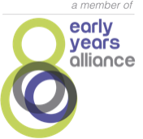

The St Mary’s Pre-school is a Charitable Incorporated Organisation – Reg. No. 1171309

