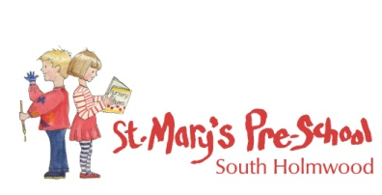
Safeguarding Children
Safeguarding children is everyone’s responsibility. Everyone who works with children – including Teachers, GP’s, Nurses, Midwives, Health Visitors, Early Years professionals, Youth Workers, Police, Accident and Emergency staff, Pediatricians, voluntary and community workers and Social Workers – all have a responsibility to keep children safe.

St Mary’s Pre School is committed to building a ‘culture of safety’ in which children are protected from abuse and harm at all times.
We are committed to responding promptly and appropriately to all incidents or concerns of abuse that may occur and to work with statutory supporting agencies and professionals in accordance with the procedures that are set down in ‘What to do if you’re worried a child is being abused’ - March 2015.

For advice and or support please speak to Tina Hillson who is the Designated Safeguarding Lead for St Mary’s Pre School.

For further advice and support please contact the following services:
- South East Area Children’s Service: 0300 123 1620
- Children’s Services – out of hours: 01483 517898
- Surrey Police: 0845 125 2222 or 999
- NSPCC: 0800 800 5000
- OFSTED: 0300123 1231

*Any enquiries are confidential and may be treated anonymous if preferred*

