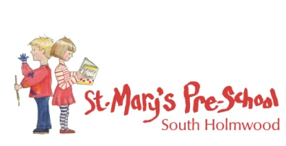
Uncollected Child
In the event that a child is not collected by an authorised adult at the end of the session/day, St Mary’s puts into practice agreed procedures. These ensure the child is cared for safely by an experienced, vetted and qualified practitioner who is known to the child. We will ensure the child receives a high standard of care in order to cause as little distress as possible.

If a child is not collected at the end of the session, the following procedure is adopted:
- The collection sheet is checked for any information about changes to the normal routines.
- If no information is available, the parents/carers are contacted at home or at work.
- If this is unsuccessful, the adults who are authorized by the parents to collect their child from the setting are contacted.
- All reasonable attempts are made to contact parents and nominated carers
- The child does not leave the setting with anyone other than those named on the Registration Form, Collection sheet, or supplied by parent using the password system.
- If no one collects the child after one hour and there is no one who can be contacted to collect the child we apply the procedure for ‘uncollected children’.

- We contact Children’s Service, South East Hub on 0300 123 1620
- The child stays at the setting in the care of two fully vetted practitioners until the child is safely collected by parents/authorised person or by a social care worker.
- Children’s Services will aim to find the parent or relative, if they are unable to do so, the child will be looked after by the Local Authority.
- Under no circumstances will staff go to look for the parent, nor do they take the child home with them.
- A full written report of the incident is recorded in the child file and Safeguarding file.
- OFSTED (0300 123 1231) will be informed when Children’s Service or the Police are contacted.

